.
The Autumn 21 Newsletter

Farewell Tea Party for the Magees
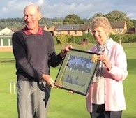
Club members gathered to bid farewell to David and Eileen Magee at a “Farewell Tea Party” held on Friday 22nd October. David and Eileen have given many years of continuous, unselfish devotion to the club. Not only have they spent many an hour contributing to keeping the club, its lawns and building surrounds tidy and appealing, but they both have enjoyed being active members of our wonderful club.
The tea was arranged to say thank you to the Magees, who were presented with many gifts from the club’s members to show their gratitude and thanks. The Committee have given David and Eileen Lifelong Membership of the club.
Car Park
I am sure you will all agree that Robin Hayes has made a magnificent job of tidying up and extending the car park. Robin asks that you do not get too close to the new fence, as it will take some time for the concrete supporting the new fence posts to gain full strength. In any case, driving or backing into the new fence is sure to cause some displeasure! Please park with consideration for others, so that the best use can be made of the available space.
And the infamous pile of sand is no more!
Lawn Talk Jim Blenkinsop writes:
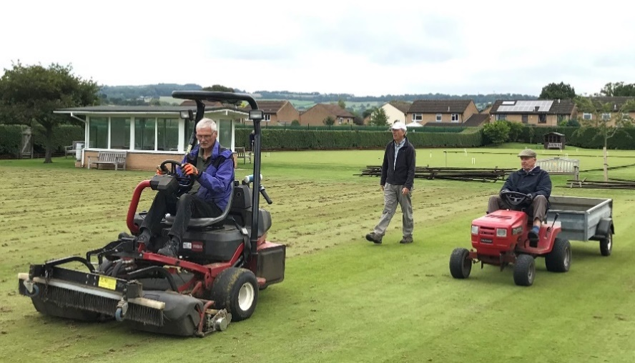
With the recent warm weather, we have seen the lawns full with both the very popular GC rollup and Blumer competitions under way. This is great to see.
The autumn maintenance, although disruptive also enabled play through October so all in all a lot more croquet has been played this autumn.
We will inevitably get some winter soon and with it conditions where some or all lawns are closed. The decisions are often last minute, where for instance a frosty morning persists, so please check the lawn booking system before going to the club. I will not be using the club answerphone to notify lawn closures.
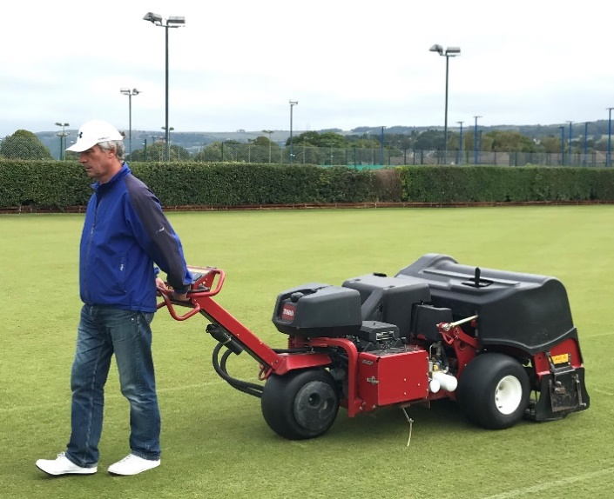
I don’t wish to be a nag, but a gentle reminder for all players.
- Please avoid walking on the corners to and from your lawn - there are some plastic barriers but all corners are difficult to maintain.
- We aim to switch/brush lawns before play but at weekends and some days this is not possible so if it hasn’t been done you must do it yourself before play.
- A lawn with hoop 1 removed means the lawn is closed and must not be played irrespective of any booking.
- Please read the blackboard by the entrance for the latest info.
Finally, a big thanks to the many volunteers who have helped this year. By my calculations there have been 150 hours of often hard labour! It has made a huge difference.
AC Referees
Congratulations to Julia Lowery and Roger Willbourn who after attending an all-encompassing 2 day laws course, run by David Magee, passed all three stages of the AC Referee qualifying exam, 2 written papers and a practical, with flying colours. Well done to them both!

Coaching Sarah Hayes writes:
The promised GC Coaching has taken place with 3 of the country’s top GC coaches coming along to present one day sessions. These were well attended; the weather was kind, and everyone seemed to enjoy themselves.
Klim has written about the Short Croquet and GC2AC – many thanks to Klim for all this extra work which is much appreciated.
AC coaching is still attracting a good number of players on a Tuesday morning with several new players progressing well – watch out as I hope they will all be out there armed to the teeth with bisques next season!
Saturday coaching has moved to the mornings to take advantage of the daylight. I am using the first part of the morning session to present a 4-ball break course to all our high handicap beginners which will take 6-8 weeks and I think (fingers crossed) everyone is having a good time. The second half of the Tuesday and Saturday sessions are looking at Peeling turns, and a keen handful of players are becoming quite proficient so don’t say you haven’t been warned.
Our coaching team has kept busy with Taster sessions and Newbie requests which have led to interest for next season hopefully – it is a bit grim to learn from scratch in the freezing cold – and giving our newly accredited personnel some experience to boot – so all good!
Please do send all coaching requests to me on burrowsarah5@googlemail.com.
Short Croquet Klim Seabright writes
As a member of the Croquet Association Council, I was aware of the increasing growth in Short Croquet, especially in the North of England and the South West, and I did not want Cheltenham to miss out.
Fortunately, I found an interested party in Adam Moliver, and we presented a paper to the committee, which gave permission to test the level of interest. We were both pleasantly surprised at the response. By the time that you are reading this newsletter the first 20 members should have received their training but Cumulonimbus intervened and we are re-scheduled for the 26th November. There are also 6 on a waiting list. We have been fortunate in obtaining the voluntary services of Paul Francis from Bath for this training.
The committee has agreed that short croquet can be played, probably with two courts on Lawn 11, and Jim Blenkinsop is also considering giving the practice area a makeover which can then form a Short Croquet Court. We will also be looking to form a squad of players to enter one of the South West Federation Leagues. I also understand that Short Croquet will be included at future Members Days.
I cannot speak for Adam, but in my Tournament Travels (a good way to improve your croquet) there is clear and significant “shrinkage” of Association Croquet. I enjoy both AC and GC, but hope Short Croquet might help preserve the sport.
Short Croquet also appeals across the range of handicaps. Low handicaps get involved in wiring and peels. If you would like to be added to the Short Croquet waiting list then let Klim know.
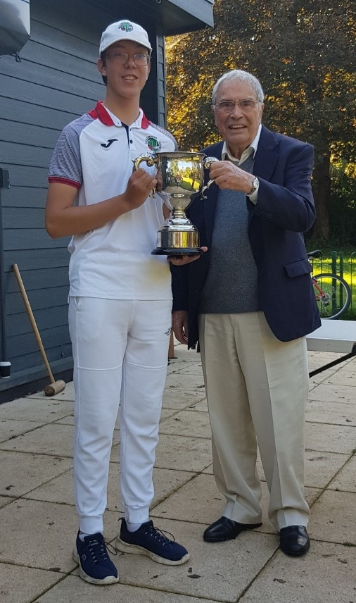
Under 18s Deborah Albertsen and Naomi Whitehead write:
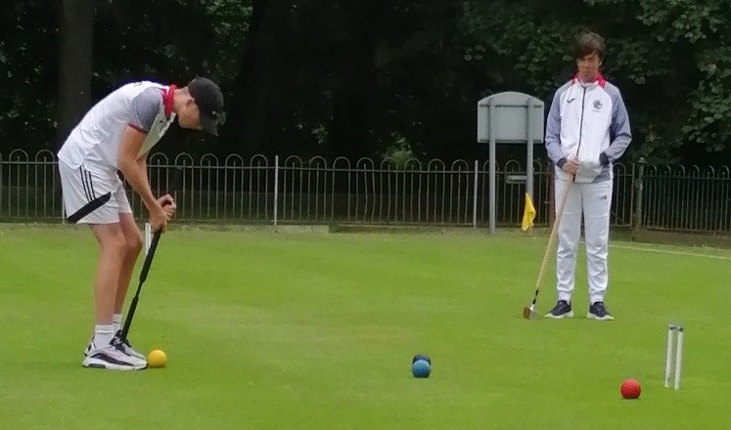
The Club’s Under 18s are going from strength to strength!
After a successful 2021 season both home and away, most notably winning the Walter Peel Memorial together during Festival Week, Harvey Smith and Sam Cuthbert travelled to Watford CC in October, to compete in the National AC and GC Junior Championships (above). In unexpected but glorious sunshine, Harvey (4) faced the much more experienced Albie Willett (-1) in the GC final. He made an excellent start, taking his opponent to the ‘golden hoop’ in the first game but was eventually beaten in straight games.
In the AC Championship both Harvey and Sam progressed through the block qualifier only to meet in the semi-final. Sam won and went on to beat Albie (the defending champion) in the final by a margin of 16 points. Afterwards, the CA President, Quiller Barrett, presented Sam with the Charles Townsend Cup (above right).
These events are not only a chance for these young people to compete but also an opportunity to meet up with other school age competitors from various clubs and share their experiences. They have also played as members of League teams and entered various tournaments. They could not attend these different events without the encouragement of their parents who accompany and support them. This Autumn and Winter the Under 18 group has had the benefit of Andrew Cowing who has been coaching them.
GC to AC – or – GC2AC Klim Seabright writes
I thought it would be good to come up with a "snappy" title! I offered GC only players an opportunity to sample some AC. Thinking that I might get one or two takers, then imagine my delight when 6 came forward and 4 have continued with an interest. I tried to design a two session input taking on board comments made by GC players about AC (real or imagined).
A big “thank you” to Lawn Manager Jim Blenkinsop, who allowed Lawn 11 to be turned into two half lawns. I tried to translate "AC Language" into "GC Language" as much as possible. I explained some of the alternatives to 26 point games. I also explained “alternate stroke” doubles to be a bit more “sociable” than straight AC doubles.
It was great to have fellow coaches Peter, Michael and Julia as part of the coaching team. If any GC only players out there would like two sessions along the same lines, then please contact me on klimseabright@gmail.com.
One of the participants wrote the following, ""Many GC players find getting to grips with AC daunting and often confusing, and I was one! How to open, where to place the balls, what strokes to use….confusion big time!
“I am still very much learning all this, but the small group of around 6 along with coaches has been incredibly helpful. We took it slowly, learning one aspect of the game at a time, like understanding the different strokes, setting up a four ball break and guidance on how to practice all of these. The small group meant coaches were always on hand able to help and observe us.
My only wish is that the sessions had continued over more weeks, but it was a great introduction to AC and I’m grateful for all the time the coaches gave to us. Less confusion now, but much more practice and coaching needed ahead!”
Changes in the Committee and in the Kitchen
Sarah Hayes has taken over from David Magee as the club’s Treasurer, in so doing she has relinquished her role as Chairman. However, Julia Lowery has remained as Vice Chair and will chair all committee meetings up to the next AGM.
Jim Blenkinsop has taken over David’s role as Lawns Manager.
In the kitchen, Pat Francis has kindly volunteered to take over and fill the (large) gap left by Eileen Magee.
Polo Shirts Naomi Whitehead writes
I am hoping to buy some polo shirts with the new logo on for members. You would have received an email about this, but if you need to know anything please phone or email me. I am planning to have a couple in the clubroom for you to look at. I have also been asked if a shirt could have an individual's name on and this is possible at the extra cost of £2, making the total for the shirt £17. Also, the company can supply an adjustable cap with the club’s name on at the cost of £9. I would like an idea of numbers required before I order them, so either write your name down as ‘interested’ on the sheet at the club or let me know by email -nao.whitehead@gmail.com
Toilets
Robin Hayes has completed a most unpleasant task. He has sorted out our drains, which he found to be blocked by absorbent pads (enough said). The drains are now running freely, and I am assured that the gents toilet no longer suffers from an offensive odour.
Robin asks that if you do encounter problems in the future, please let him know straight away.
100 Club
Recent winners are as follows
 | First | Second | Third
September 21 | Adam Moliver | Robert Richardson | Russell Barter
October 21 | Deborah Albertsen | Russell Barter | Bob Knight
November 21 | Deborah Albertsen | Maryse Roberts | Roger Willbourn

John Gilden
24 November 2021

